1. Creating a Table – Create the Cars table. As a reminder, make sure to follow along in the Lab 1 Explanations document as it shows you how to create tables and complete the other steps.

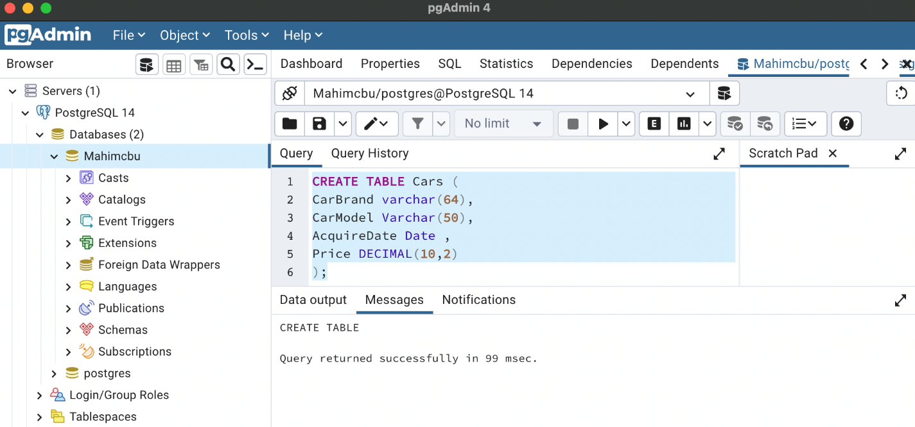

2. Inserting a Row – Insert the first row where the Car Brand name is “Ford”, the Car Model is “Econoline Full-Size Van”, the acquisition date for the car is August 15,2021, and the price is $29,995.00.

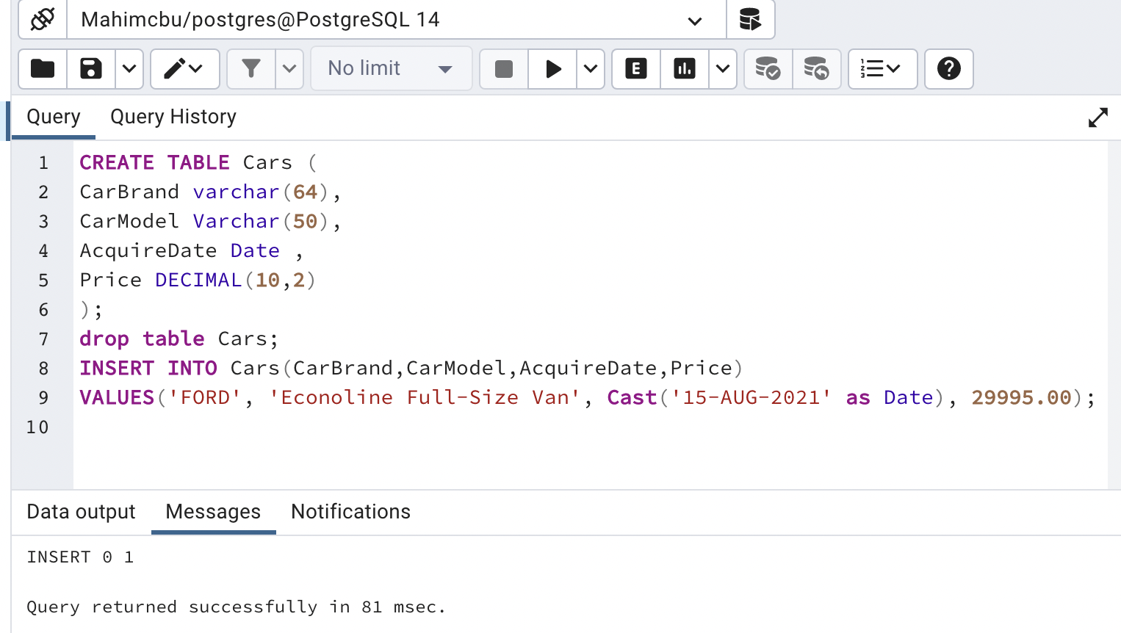

3. Selecting All Rows – Select all rows in the table to view the row you inserted.

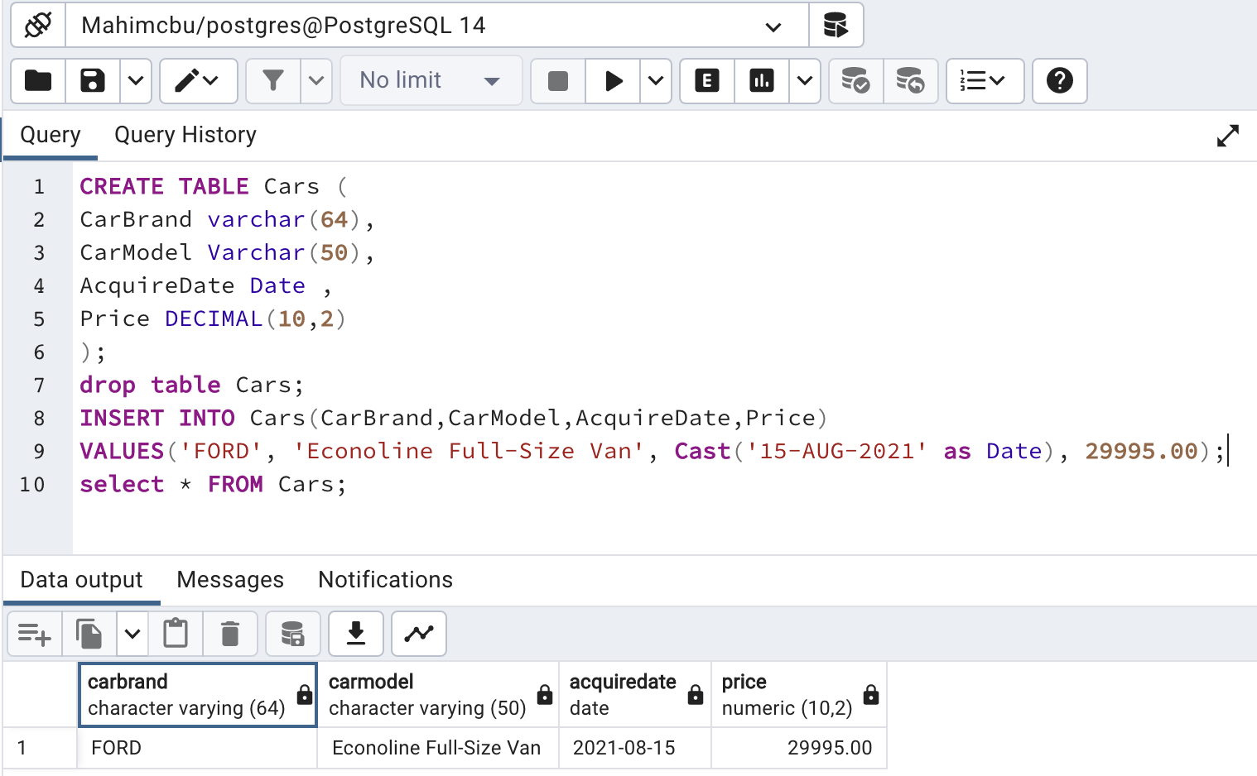

4. Updating All Rows – Update the price of the row in the table to $28,000, then select all rows in the table to view the row you updated.

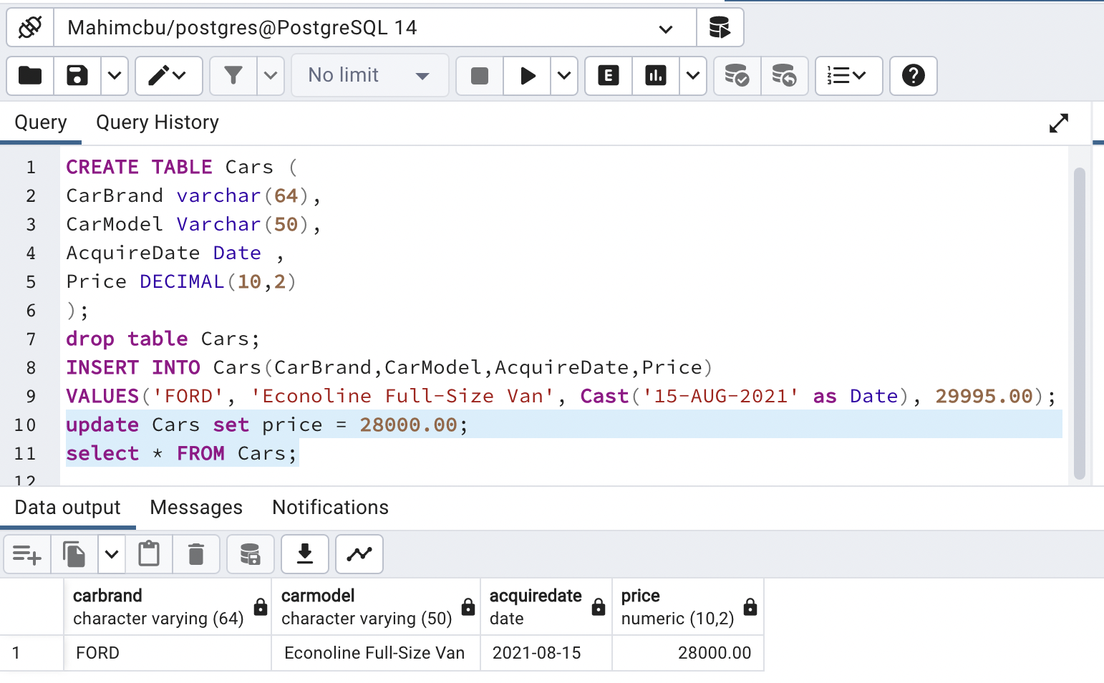

5. Deleting All Rows – Remove all rows from the table, then select all rows in the table to verify there are no rows.

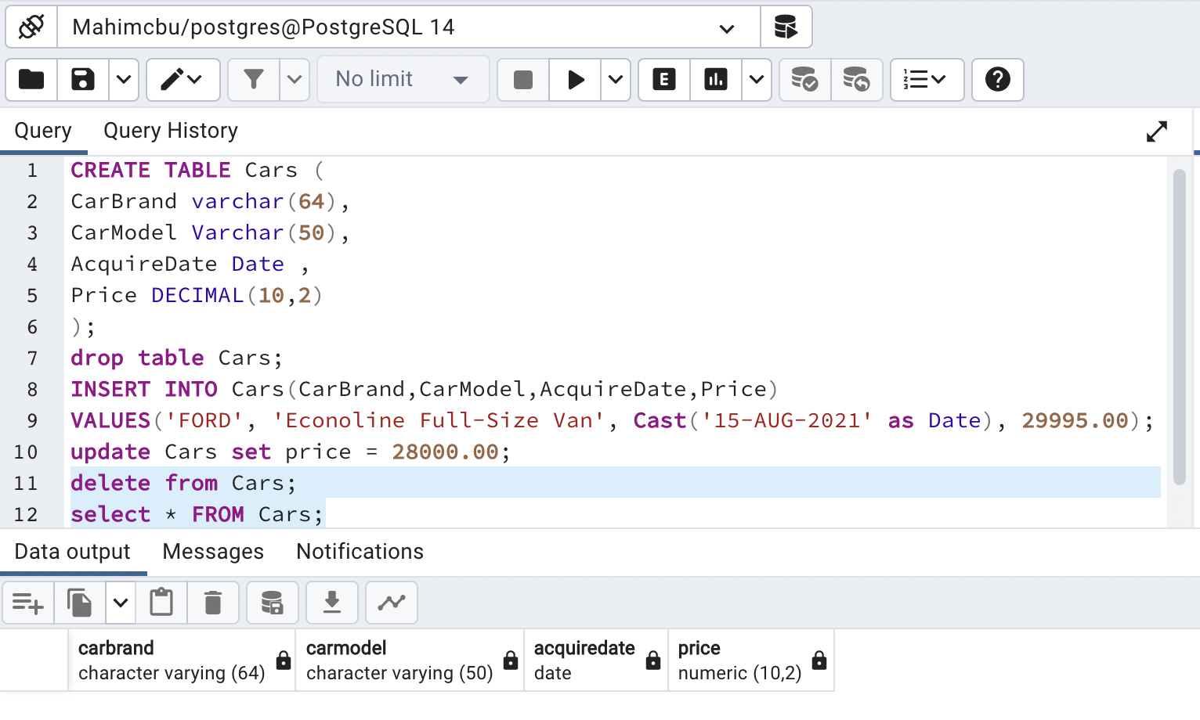

6. Dropping a Table – Drop the Cars table, then select all rows in the table to verify the table doesn’t exist. Explain how you would use the error message, in conjunction with the SELECT command, to diagnose the error.

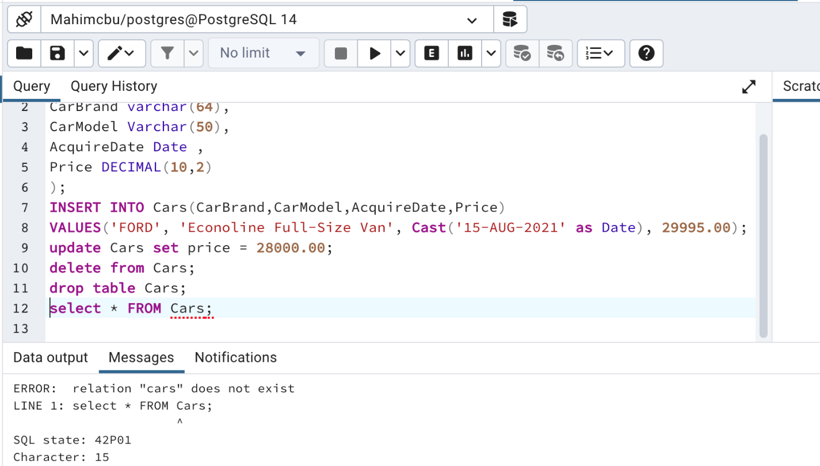

Explanation: Because the drop command gets rid of the entire table "Cars", there are no rows for the "Select" command to work off of. For the "Select" command to work, it needed the "Cars" table to exist first.

7. Table Setup – Create the Apartments table with its columns, datatypes, and constraints.

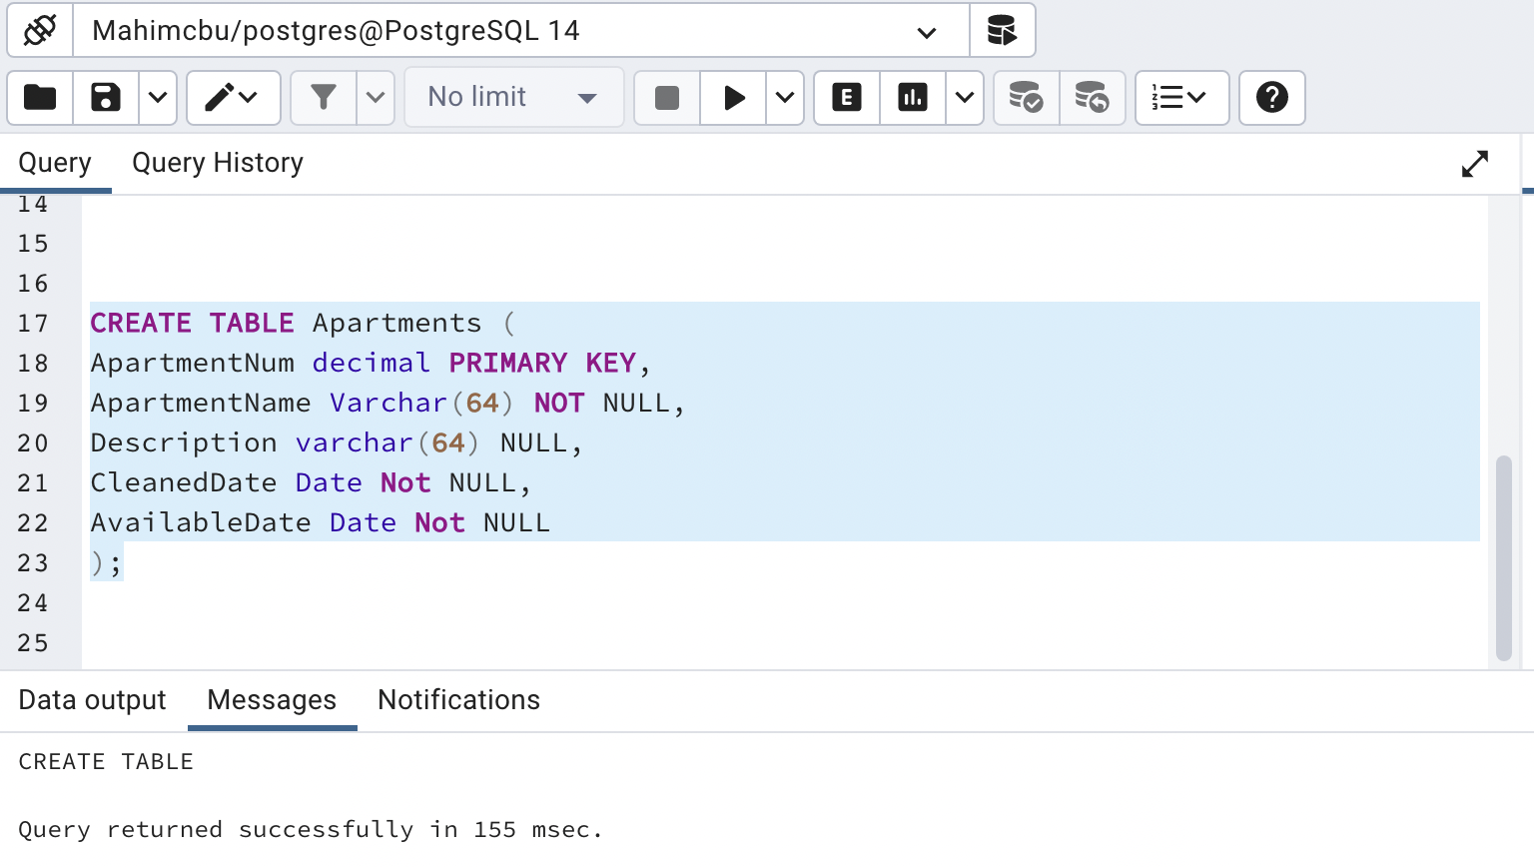

8. Table Population – Insert the rows illustrated in the figure above. Note that the description for Apartment 316 at Paradise Palms is null. Then select all rows from the Apartments table to show that the inserts were successful.

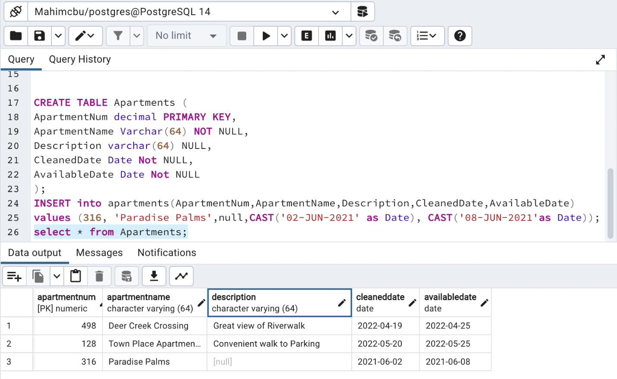

9. Invalid Insertion – The following values leave the Apartment Name with no value.

ApartmentNum = 252

ApartmentName = NULL

Description = Close to Downtown shops

CleanedDate = 17-JUL-2020

AvailableDate = 13-JUL-2020

a. In your own words, explain what a null value is.

- a. A null does not mean empty. To me, it's like a placeholder where we don't know the value yet. Null could be a 0 value or it could be anything that we don't know yet.

b. In your own words, explain what a NOT NULL constraint is.

- In contrast to null, a "not null" constraint forces the field to contain a value that can be known. In other words, a field has to have a value unlike a null constraint, or else it will generate an error

c. Attempt to insert the values as listed and explain how the database handles this attempt.

Explain how you would interpret the error message and conclude that the location column is missing a required value.

- The error clearly states that the column "apartmentName" violates the not null constraints because we attempted to put "null" in that field. As I mentioned in part b above, sql has correctly identified the error and reported where the not null constraint has been violated.

10. Valid Insertion – Now insert the row with the Apartment Name intact, with the following values.

ApartmentNum = 252

ApartmentName = The Glenn

Description = Close to Downtown shops

CleanedDate = 17-JUL-2020

AvailableDate = 13-JUL-2020

11. Filtered Results – Retrieve only the Apartment Name and the Description for Deer Creek Crossing, using the primary key as the column that determines which row is retrieved.

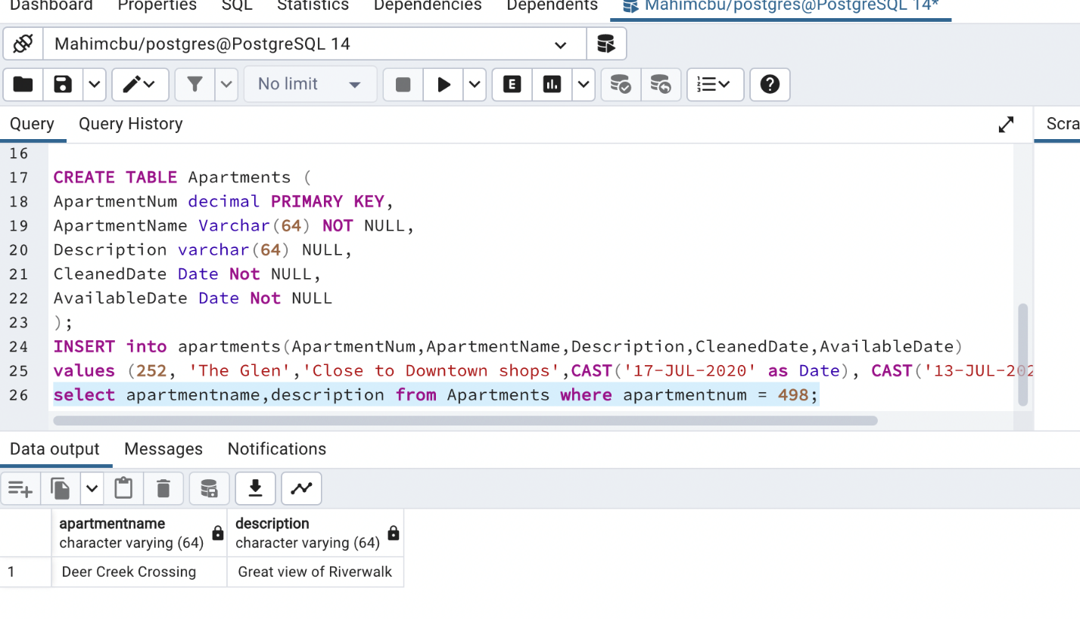

Explain why it is useful to limit the number of rows and columns returned from a SELECT statement.

- Limiting the number of rows and columns in a database allows the user to modify only that specific row or column instead of selecting all the rows and columns. In other words, limiting rows and columns with SELECT statement allows you to filter the database.

12. Targeted Update – The Paradise Palms apartment has no description. Update the row so that its description says “A mile walk to the beach”.

Select all rows in the table to show that the update was successful.

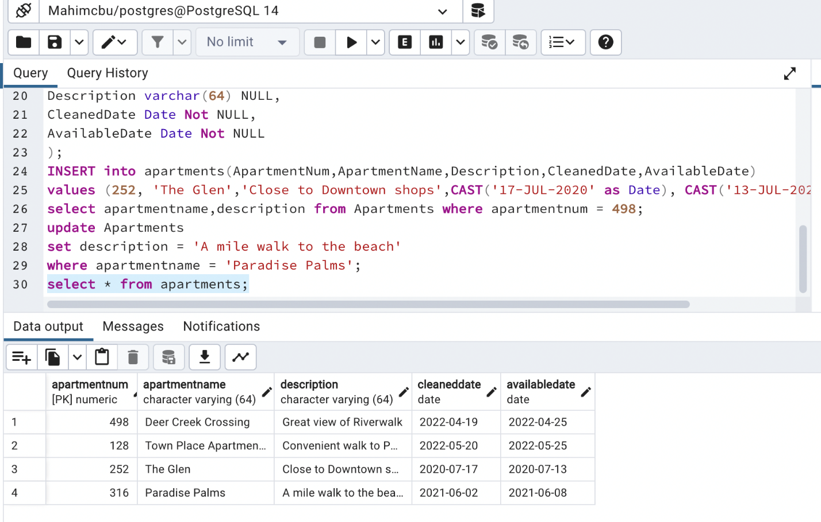

13. Updating to Null – Update the Town Place Apartments so that it no longer has a description (i.e., its description is null).

Select all rows in the table to show that the update was successful.

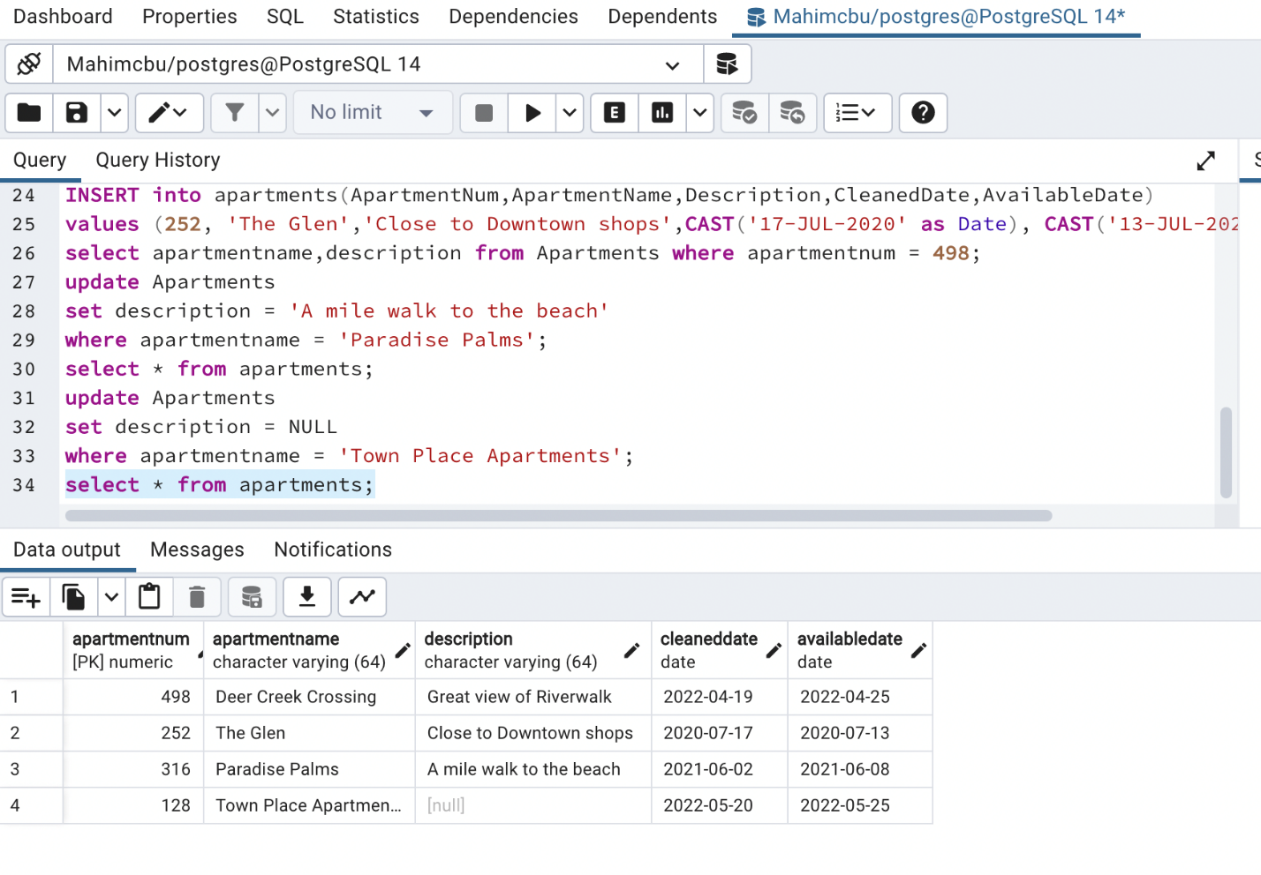

14. Targeted Deletion – Delete all rows where the Cleaned date is greater than April 1, 2022, by using the Cleaned Date column as the determinant of which rows are deleted.

Select all rows in the table to show the delete was successful.

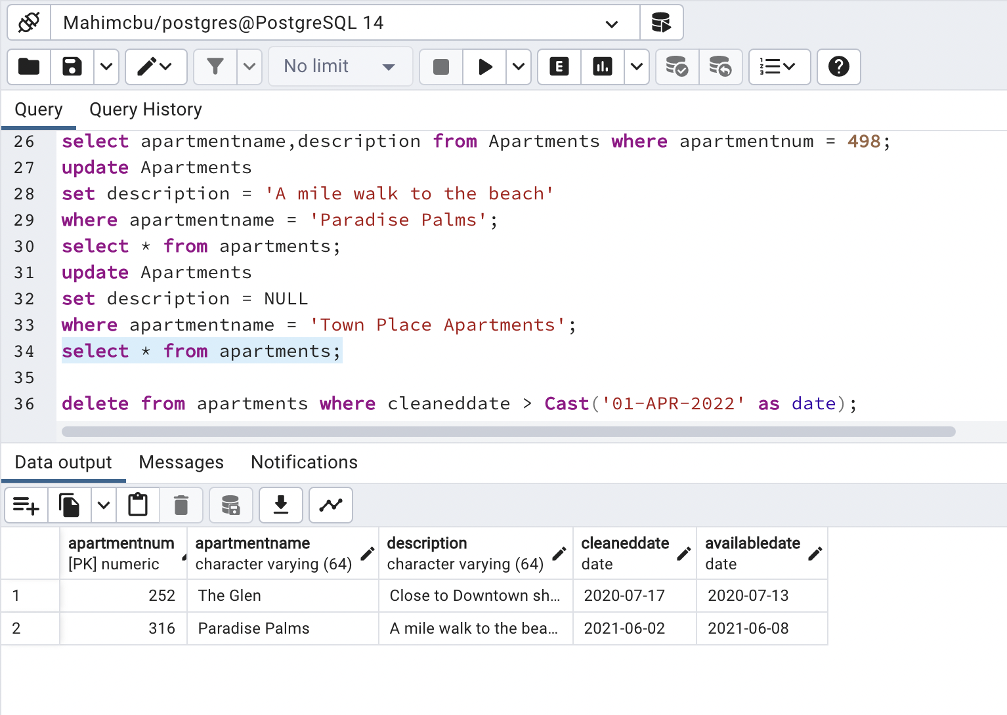

15. Data Anomalies – In this step you demonstrate anomalies that can occur in improperly designed tables.

a. Create a table of your choosing that has at least three columns.

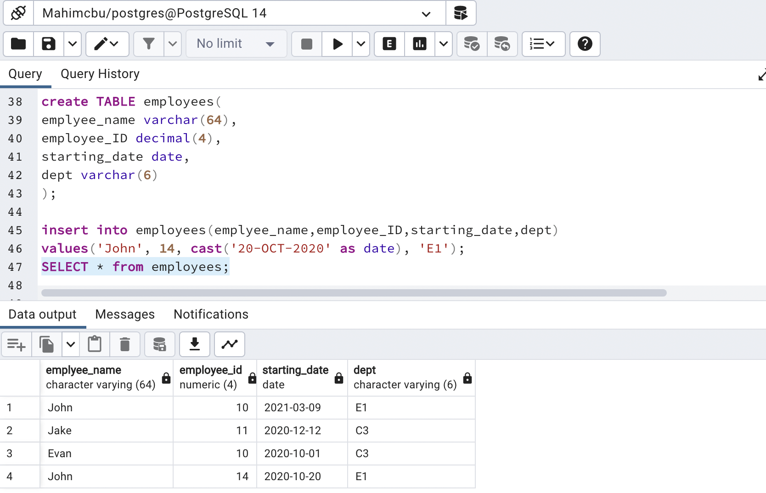

b. Using the table, demonstrate an anomaly that occurs when the same data is inserted multiple times with different values, and explain what the anomaly means for data integrity.

If the table was designed improperly, meaning only the employee_name, starting_date, and dept were the only columns, there's no way for anyone to identify which John to look for since there's no employee id. Because we added two "John" in the same department, we need to distinguish them by an employee id column. There could be an update anomaly if we want to update "John" department for example, how would you know which John's department to update had there been no different id number? An update for the dept of one John would disagree with other John if the employee Id is not used to differentiate them. So anomalies can happen multiple data is inserted and if the table isn't designed properly to distinguish every inserted value. These data anomalies can seriously damage the database's reliability and question the integrity of the db design.

c. Using the table, demonstrate a deletion anomaly with SQL, and explain what the anomaly means for data integrity.

When I deleted employee_name "John” from the employee table, it deleted all the other "John" repeated in the table which is unwanted. So, if not careful, this could create a deletion anomaly as someone can destroy information if the correct filters are not used.

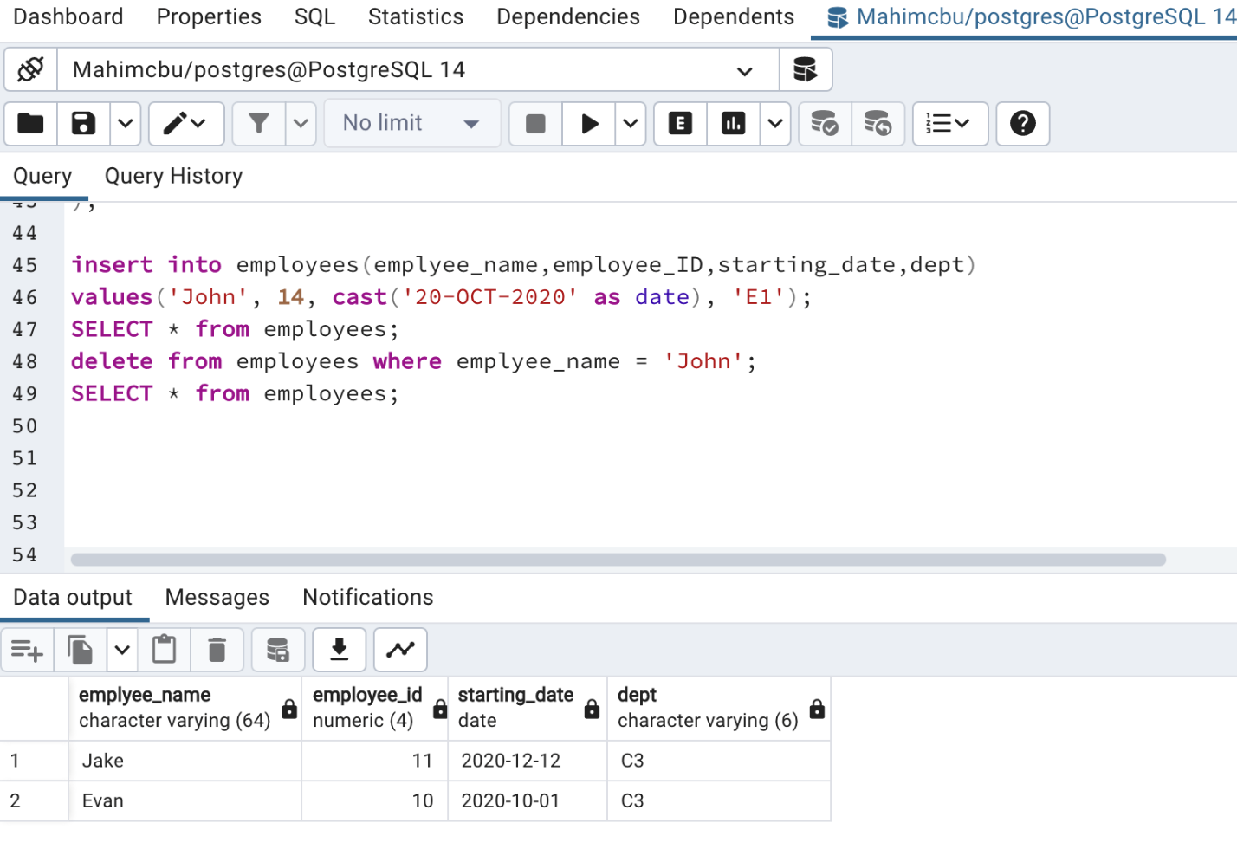

16. File and Database Table Comparison – In this step you compare the table created in #15 with a file that contains all the same information.

a. Create a file in any format you’d like that contains all the same columns and at least 4 rows of information as the table you created in #15. There are many formats you can use. Some examples include XML, flat file, binary, text, and JSON; this list is not exhaustive. All columns and at least 4 rows should be present in the file in its new format. Make sure to provide the file or a screenshot of the file and to explain your choices.

- I wrote a text file where the first row represents the columns separated by a comma. The rest of the rows represent data for each column separated by a comma.

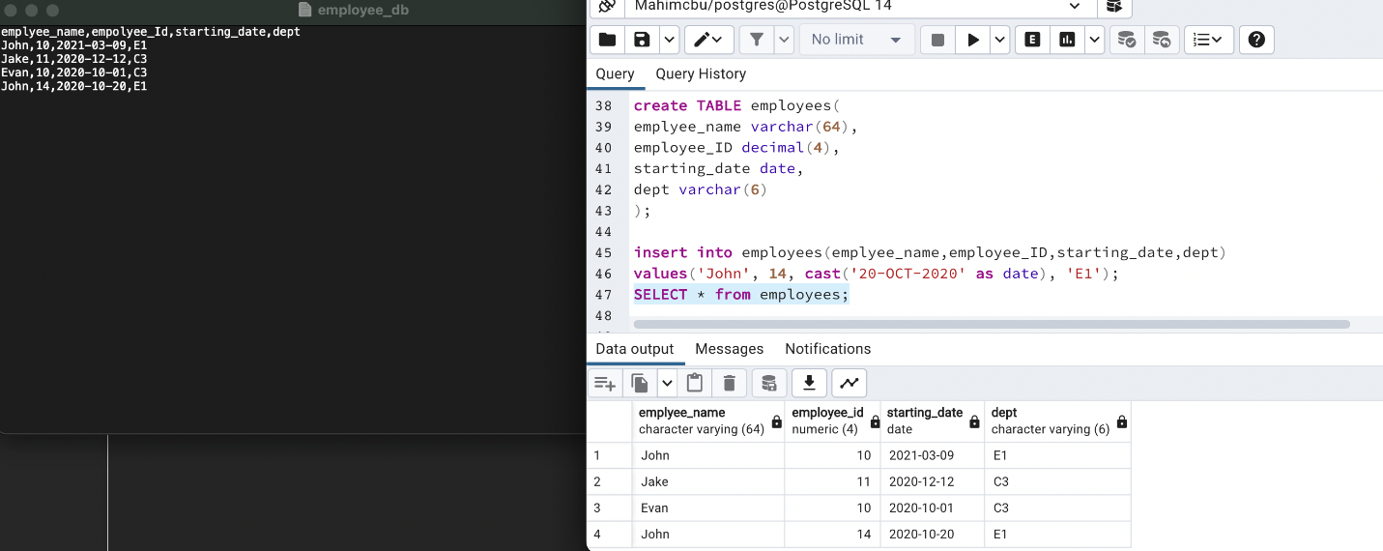

b. With a few paragraphs, compare what it’s like to access data in the table versus in the file. You may need to first research how applications typically access data in this type of file. Make sure to at least use these comparison points:

i. Efficiency – If there were millions of rows of data, would it be more efficient to access a single record in the relational table, or the file, and why?

ii. Security – Imagine you needed to restrict access to one specific row/record, allowing only one person to access it, while the rest of the rows could be accessed by many people. Would it be easier or more difficult to secure this row in the relational table compared to the file, and why?

iii. Structural Independence – Imagine the table structure was modified by adding or taking away columns, and equivalent changes were made to the file. Would these changes affect an app using the table differently than an app using the file, and why?

- Efficiency:  When handling large sets of data, it is clearly visible how the structured data in the database table makes life so much easier to insert or update data as opposed to a flat file. In a flat file system, inserting or updating something will be really error prone especially if there are tons of data whereas in the database table since it is an indexed system, it is much more structured and easier to access data, insert, and update data.

Security: According to Professor Warren's lab1Explanation document, A file system does not provide security at the lower level of its content. However, a database table can provide security for each row or column of data. So, this is very clear which data storage system is more secure than the other. File systems can never be trusted if someone wants to privatize a certain portion of the data within the file whereas, in a database table, they can. In the database table, the logic of giving access to individuals to a specific row or column is easier as it is indexed. A file system can be of many formats and based on that, the logic may get very complex if a certain portion of data needs to be secured.

Structural Independence: Removing or adding a column or row in a database table should not cause problem to the app that is using the database table as it is dynamic. A flat file is file saved with certain length, data, location, etc. If a change is made to it, the app should be made aware of it manually which is an extra work on the developer side. Also, if not careful, an update to the file could easily break the app as the file system may not be always written with very good structure opposed to a database table.